# HELPTAG 365 PRIVATE LIMITED

Surat,Gujarat

+91 87994 55365

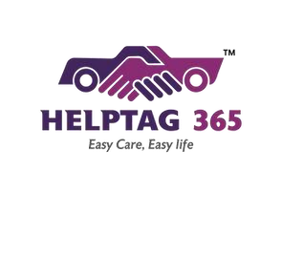

[helptag365@gmail.com](mailto:helptag365@gmail.com)

**Date: 01-03-2025**

**PROGRESS REPORT**

**Name:** Harsh Bhimjiyani **Enrrollment No:** ET23MTCA007

**Duration:** 17/02/2025 – 28/02/2025 **Group Number:** 26

**Project Title:** Jobjod **Project Report**: 3

**Project Guide Name:** Prashant Bambharoliya

|  |  |  |  |
| --- | --- | --- | --- |
| **Sr No.** | **Date** | | **Task Detail** |
| **From** | **To** |
| 1 | 17-02-25 | 31-01-25 | * Learning basic javascript * Basic javascript concept |
| 2 | 01-01-25 | 06-01-25 | * Learning (React.js) * Advanced React.js(Hooks,Route) * Create Website (HTML,CSS,JS) |
| 3 | 07-01-25 | 12-01-25 | * Larned React.js |
| 4 | 13-01-25 | 17-01-25 | * React Base Task Complete |

**External Guide sign Organization’s seal &**

**Signature**